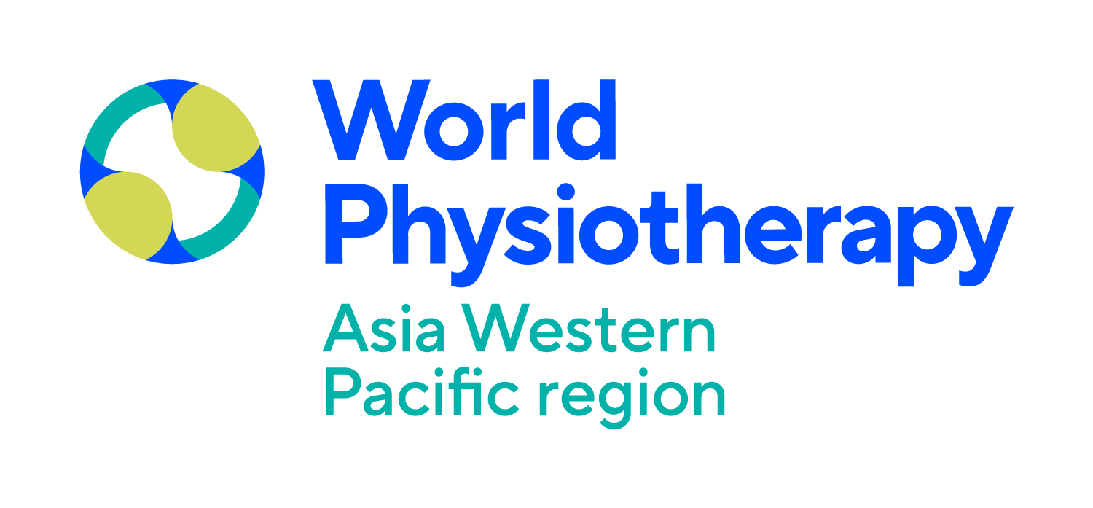

Call for abstracts
Submission: 26 February-1 May 2024
Submission guidelines
Please read this information carefully before proceeding to the online submission form

Submission process:
Apply on the congress website: https://awpconf2024bali.com/.

Important dates
Submission opens 26 February 2024
Submission deadline 1 May 2024
Notification of outcome June 2024

Abstracts

This is an opportunity to submit your most recent research and have the insights presented at the World Physiotherapy Asia Western Pacific Congress 2024 in Bali.

In the submission system, you will be asked when your project has been completed to ensure the most recent research is identified. Abstracts are invited that:
- report on the latest research with original scientific data [this includes systematic/narrative reviews and meta-analyses]; submissions with pending results and study protocols will not be accepted.
- address new and unique developments in practice, theory, education, management, policy, and resources.
- describe innovative ways in which established methods have been adapted to meet the changing needs of practice.

Successful abstracts will be scheduled in specific abstract platform presentation sessions if they meet the high standard of scientific merit for this category. All other abstracts that are submitted and do not meet the criteria will be reviewed and considered by the congress program committee but will be scheduled as poster presentations and will not be included in the abstract presentation awards selection.

Presentation format
Abstracts are presented either as an oral or as a poster presentation. All presenters must attend the in-person congress in Bali and can register using the presenter rate (terms and conditions apply).
Oral presentations
Each oral presentation is scheduled for eight minutes plus two minutes for questions.
Poster presentations
- Printed poster presentations are grouped by topic within the poster area.
- Presenters have a designated presentation time during the lunch break onsite for discussion with participants.

Selection criteria
Submitted abstracts will go through a blind peer-review process by international reviewers. The following topics:

Musculoskeletal and Orthopedic

Neurology

Pediatric

Sports and exercise

Cardiorespiratory

Gerontology

Women’s, Men’s, and Pelvic Health

Acupuncture and dry needling

Cancer, Palliative care, and Lymphoedema

Mental health

Aquatic

Disability

Occupational health

Physiotherapy Education

Submission guidelines
All correspondence will be with the person who submits the abstract online. The presenting author does not have to be the first named author listed in the abstract and will be identified through the submission process.
The online submission form will provide restricted space for data entry; the available word count is indicated below, and the system will impose the limit.

You will be asked to provide the following:
- Preferred presentation format (oral or poster)
- Fit with Congress's topic area(s).
- Title of abstract [maximum 20 words].
- Completed abstract [maximum 300 words]. Abstracts will be included in the congress proceedings and must be structured using the headings below.

Heading | Notes
1. Background: | What was the context for the study/project? Why was it important that this project was undertaken?
2. Purpose: | What was the major reason for undertaking the project? (A project may be a research study, developing a new or adapted programme, method, theory, or resource). Any secondary objectives?
3. Methods: | What principles, methods/methodological approaches, materials did the project involve?
4. Results: | Summarise the main findings from the analysis.
5. Conclusion(s): | What can be concluded from the study? What are the suggestions for future work?
6. Implications: | What are the implications of the project and how will the results be translated into physiotherapy practice/management/education/policy.

No images, tables, or graphs are permitted. References are not required in the abstract.
- Keywords: use up to three words to describe your work that is supplementary to the program topic(s)
- Funding acknowledgments: please acknowledge all funding sources that supported your work. If the work was unfunded, please state this [maximum 20 words]
- Ethics approval [see general information point 11 below]: evidence that ethics approval was given is required. Please name the institution and ethics committee that approved your work or advised you that it was not required. Provide the ethical approval number or state the reasons why ethics approval was not required.
When submitting your abstract, you will be asked, "Did this work require ethics approval?". If not, you will be asked for the institution and ethics committee that advised you that ethics approval was not required and the reasons for it. You will be asked to upload supporting evidence.
Ethical approval is unlikely to have been required if your work:
  - addresses new and unique developments in practice, theory, education, management, policy, and resources.
  - describes innovative ways in which established methods have been adapted to meet the changing needs of practice.
  - is a systematic or narrative review.
The Council for International Organizations of Medical Sciences (CIOMS) in collaboration with the World Health Organization, has developed the ‘international ethical guidelines for health-related research involving humans’ which provide examples of exemptions from review (see page 90) https://cioms.ch/wp-content/uploads/2017/01/WEB-CIOMS-EthicalGuidelines.pdf
In these cases, please state N/A for the institution and ethics committee, and complete the reason ethics approval was not required, giving as much detail as possible [500 words]
- Presenter details and biography of presenting author [200 words].
- Co-author details.
- Information concerning any presentations or publications of the work made before congress [50 words].

General information
- The congress language is English, and all proposals and presentations must be in English.
- A written abstract in English must be submitted for each proposed presentation.
- It is the author’s responsibility to submit a correct abstract. Any errors in spelling, grammar, or scientific fact will be reproduced as typed by the author.
- The topics selected will be used to inform the review, selection, and programming processes. Please choose the topics(s) that best describe the subject of your abstract that will attract the right audience to interact with you.
- A person can only present a maximum of two abstracts. They may be named as the presenting author on multiple submissions but will only be permitted to be confirmed as the presenting author on two accepted abstracts. The confirmation system will permit a change of presenting author on accepted abstracts. They may be named on other abstracts as a co-authors.
- Only one presenting author per paper is permitted. Only an author may present the abstract. If no author is available onsite, the abstract will be withdrawn. Any changes to the presenting author must be notified directly to the scientific committee. Changes will be incorporated into the final program if there is sufficient time, but thereafter, no further changes will be reflected.
- Notification of the outcome will be sent to the submitter. Please note that only the person who submits the abstract online will receive mail concerning the abstract and is responsible for informing all authors of the status of the abstract.
- All presentations must describe original work to which all the authors listed have contributed significantly. Any reference to personal experience should be clearly labeled as such.
- All proposals and presentations must adhere to the use of “people-first” language. A person must not be referred to by disability or condition, and terms that could be considered biased or discriminatory in any way should be removed (eg “person with a stroke” instead of “stroke patients”). See www.disabilityisnatural.com/people-first-language.html for more information and examples.
- Any funding source or support for the work being presented should be acknowledged.
- All presentations, including research on humans (patients, carers, students, faculty, staff, colleagues) or animals, must provide evidence that the research was carried out ethically (i.e., ethics committee approval, informed consent by subjects). To check that your research complies with ethical principles, please visit https://bit.ly/3gHtmB2¹. See also the global international standards. The Scientific Committee expects the research to have been conducted following international principles.
- Each abstract submission must indicate if the material has been or will be published in any format or presented at another national or international meeting prior to the World Physiotherapy Asia Pacific Physiotherapy Congress 2024.

¹ With thanks to Julius Sim, University of Keele, UK, for permission to use this document.
² Declaration of Helsinki of the World Medical Association (2013) and the Council for International Organizations of Medical Sciences’ (CIOMS) International Ethical Guidelines for Biomedical Research Involving Human Subjects published in collaboration with the World Health Organization (2106). CIOMS and International Council for Laboratory Animal Science (2012) International Guiding Principles for Biomedical Research Involving Animals.

Abstracts for previously published or presented work will only be considered if they are unlikely to have reached an international physiotherapy audience and if the authors take responsibility for providing any copyright clearance needed for inclusion in the congress proceedings or other congress publications.
- The author presenting the paper must register to attend the in-person congress and be available to participate in the program as scheduled.
- The scheduling of all presentations will be determined by the Scientific Committee to ensure the best fit with the overall congress program. Any requests for specific dates and times will not be considered. Similar abstracts in related topic areas will be grouped for presentation.
- PowerPoint presentations will be available in all congress rooms.
- There will be no display area provided for professional resource materials, including computer-based programs, materials, and audio-visual resource presentations. It is expected that any resources or materials will have been designed/developed by the author(s) and MUST NOT currently be for sale commercially by the author(s) or another vendor. If featured, they must be included in the standard PowerPoint presentation or poster format.
- Presentations are not permitted to market new products, equipment, or organizations or use the presentation time to challenge or criticize competitors’ products.
- Presenting authors will only receive a certificate of presentation.
- All presentations during the congress must include the same content and follow the same outline described in the submitted and accepted abstract. Exceptions will only be allowed with written permission of the chair of the Scientific Committee.
- In keeping with World Physiotherapy policy, no honorarium, fee, or payment of expenses will be paid to presenters.
- All decisions of the CPC are final.

Consent and permissions
In submitting an abstract, you must confirm that:
  - you accept responsibility for the accuracy of the submitted abstract and understand that the content cannot be modified or corrected after the submission deadline and that it will be published exactly as submitted.
  - all co-authors are aware of and agree to the content of the abstract and support the data presented.
  - all presenters have agreed to participate at the congress, should the proposal be accepted for presentation, and take responsibility for their travel, accommodation, and registration costs.
  - you accept responsibility as the contact person for all correspondence about the abstract and for sharing information about its status with all authors.

  - you have secured any copyright/permissions clearance required relating to any previous presentations, equipment, or other material for inclusion in the World Physiotherapy Asia Western Pacific Congress, proceedings, or other congress publications
  - for all studies (including service evaluations and audits) involving human participants or animal subjects, permission has been obtained from the relevant ethics committee where applicable, and properly informed consent given where appropriate both for the work completed and the intent to present.
  - anyone identifiable in the abstract and presentation has consented to be included.
  - the work is original, except for extracts from copyrighted works used with permission from the copyright holders, and it does not infringe upon any copyright, proprietary, or personal right of any third party.
  - you have identified any potential conflicts of interest eg financial interest in products or processes described in the abstract, stock ownership, membership on an advisory board or board of directors, or other substantive relationships

Copyright
On behalf of any co-authors, the submitter will confirm the:
  - consent to have authors’ names, affiliations, and biographical materials used in connection with the publication of your work.
  - content belongs to the author(s). However, if the abstract is accepted, the submitter agrees, on behalf of all co-authors, to transfer and assign to World Physiotherapy Asia Western Pacific free of charge, on a non-exclusive basis, the rights to edit, publish, reproduce, reformat, distribute in whole or in part the abstract and prepare all type of derivative works. These works may include press releases, recordings, and/or educational products using all communication tools and means now known or hereinafter developed, including any analog and digital means and any support or forms of media now known or hereinafter developed. This includes use in indexes or search databases in print, electronic, or other media.
  - author(s) retain the right, after the presentation, to subsequently include the work in articles, books, or derivative works that they author or edit, provided said use does not imply the endorsement of World Physiotherapy Asia Western Pacific.
  - the author(s) will retain the copyright of their abstract. However, the author shall only reuse, reproduce, or post the abstract with acknowledgment to the initial and first publication or presentation at a World Physiotherapy Congress Asia Western Pacific 2024 event and, therefore, reference the name of the World Physiotherapy Asia Western Pacific event and the date.
When completing the online submission process, the submitter will be asked to confirm that the presenting author has read and understood the general information and the requirements they are expected to fulfil.

